**INTRODUCTION**

LinkedIn has become a pioneer in professional networking in today's linked world, revolutionizing the way people and companies interact, exchange, and expand within their respective sectors. Since its founding in 2003, LinkedIn has gained widespread recognition for offering professionals a dynamic platform to display their skills, look for employment, and grow their networks. By providing a convenient, centralized platform for networking, career growth, and knowledge exchange, LinkedIn has revolutionized traditional professional contacts with its large user base and state-of-the-art capabilities. The software architecture and design components that are essential to the LinkedIn platform are thoroughly examined in this Software Requirements Specification (SRS) paper.

The expected functionality and performance criteria of the system are governed by the functional and non-functional requirements described in this document. Functional requirements outline the key features—like profile maintenance, job searching, networking, and content sharing—that LinkedIn must have in order to satisfy user expectations. To build trust and engagement among LinkedIn's professional user base, non-functional criteria, on the other hand, concentrate on the platform's quality qualities, such as scalability, stability, security, and user experience.

In order to achieve these goals, the architectural framework that underpins LinkedIn's application is essential. LinkedIn's development is guided by best practices that prioritize strong data handling, adaptability, and user-centric design. UML diagrams that show the architecture of the system and how its many components interact are also included in this SRS document. For stakeholders, these diagrams are crucial tools since they provide understanding of the system's architecture and point out areas that could use improvement.

**REQUIREMENTS**

***Functional Requirements***

**User Profile Management**:  
Users must be able to create, update, and delete their professional profiles, including personal details, work experience, skills, and education.

**Networking and Connections**:  
Users should have the ability to send, accept, or decline connection requests, and view mutual connections within their network.

**Job Search and Applications**:  
LinkedIn should allow users to search for jobs, apply directly through the platform, and receive job recommendations based on profile data.

**Content Creation and Sharing**:  
Users must be able to create posts, share articles, images, and videos, and engage with content via likes, comments, and shares.

**Messaging and Communication**:  
Real-time messaging functionality must be available for users to communicate with their connections, recruiters, and colleagues.

**Notifications**:  
The platform should provide timely notifications for connection requests, messages, job alerts, and activity on user posts or profile.

**Groups and Communities**:  
Users must be able to join, participate in, and create professional groups, allowing discussions and knowledge-sharing within specific industries or topics.

**Premium Features Access**:  
LinkedIn should offer premium features such as InMail, enhanced job insights, and learning resources for premium subscribers.

**Skill Endorsements and Recommendations**:  
Users must be able to endorse skills of their connections and write recommendations for colleagues.

**Learning Platform Integration**:  
Access to LinkedIn Learning courses should be available, allowing users to improve their skills and display completed courses on their profiles.

**Recruiter Tools**:  
Recruiters should have access to features that help manage job postings, screen candidates, and contact potential hires directly.

***Non functional requirements***

**Scalability**:  
The system should be capable of handling a large number of concurrent users and support global expansion as the user base grows.

**Performance**:  
Pages and features should load within an acceptable time frame (e.g., under 2 seconds) to ensure a smooth user experience.

**Reliability**:  
LinkedIn must maintain high uptime (e.g., 99.9%) and resilience to ensure continuous access for users worldwide.

**Security**:  
The platform must implement robust security measures, including data encryption, two-factor authentication, and regular security audits, to protect user data and privacy.

**Data Privacy Compliance**:  
LinkedIn must adhere to relevant data protection regulations, such as GDPR, to ensure user information is handled and stored responsibly.

**Usability**:  
The interface should be user-friendly, intuitive, and accessible to users of varying technical proficiency.

**Compatibility**:  
LinkedIn should be accessible across major web browsers and compatible with mobile operating systems like iOS and Android.

**Maintainability**:  
The codebase should be modular and well-documented, enabling easy updates, bug fixes, and feature enhancements.

**Localization and Internationalization**:  
The system should support multiple languages and regional formats, allowing users worldwide to access the platform in their preferred language.

**Data Backup and Recovery**:  
Regular data backups should be conducted, and a recovery mechanism should be in place to prevent data loss in case of system failure.

**ARCHITECTURAL DESIGN**

***Architectural Styles***

1. **Data Flow style**

Data Flow Architecture centres around the movement of data across various components or processes. It involves a structured flow, often transforming data at each stage, and is typically implemented in pipelines, streams, or event-driven architectures that emphasize how data travels through the system.

Real-Time Data Processing: User actions, such as profile updates, connections, and job applications, flow through event-driven mechanisms that propagate changes across the platform, allowing for up-to-date information for all users.

Analytics and Recommendations Pipelines: LinkedIn gathers data on user activity, job searches, and engagement. This data flows through processing pipelines, transforming it for analytics tasks like generating job recommendations, suggesting relevant connections, and customizing content in users' feeds.

1. **Service-Oriented Architecture (SOA)**

SOA involves structuring the system into distinct services that provide specific functionalities, often communicating in a client-server model. Services are loosely coupled, making them reusable and independently deployable, which enhances scalability and flexibility.

**User Request Handling**: LinkedIn clients (web or mobile apps) send requests to back-end services for functionalities like viewing profiles, messaging, and job applications. Each service responds to these requests independently.

* **Client Request**: A user searches for jobs in a specific industry.
* **Server Response**: The server queries the database and returns relevant job postings.
* **Connection Management**: The connection service handles requests to send, accept, or reject connection invitations, making it easier for LinkedIn to manage each feature as a distinct service.

1. **Microservices Architecture**

It breaks down the system into very small, autonomous services that focus on specific tasks and operate independently. Each microservice can be deployed, scaled, and maintained independently, which enhances resilience and modularity in large-scale applications.

**Profile, Messaging, Job Recommendations, and Notifications as Microservices**: LinkedIn’s microservices structure includes separate services for profile management, messaging, notifications, and job recommendations, allowing independent development, deployment, and scaling of each service.

**Flexibility in Feature Updates**: LinkedIn can deploy updates to one microservice (e.g., enhancing the messaging service) without impacting others, ensuring continuity and minimizing downtime for unrelated services.

1. **Event-Driven Architecture**

involves services reacting to events (or changes in state) rather than waiting for periodic checks. It is well-suited for applications that require real-time responsiveness, with components designed to respond to events generated by other services or user actions.

**Real-Time Notifications and Messaging**: LinkedIn employs an event-driven model to support real-time notifications. For instance, when a user receives a message or a connection request, an event is triggered to deliver notifications instantly.

**Data Update Propagation**: Updates made by users—like profile changes, post updates, or job applications—trigger events that propagate across related services, ensuring real-time data consistency and enhancing user engagement through timely responses.

***Design Principles***

1. **Modularity and Loose Coupling**

Each service is independently operable and scalable. This modular approach ensures that services like job recommendations, messaging, and networking operate with minimal interdependencies, enhancing system flexibility and reliability. Loose coupling between components also reduces the risk of cascading failures across the platform.

1. **Scalability and Elastic Resource Allocation**

To maintain performance under varying loads, LinkedIn employs elastic resource allocation, a principle that supports automatic scaling based on user demand. By leveraging cloud infrastructure and distributed databases, LinkedIn efficiently manages system resources, ensuring uninterrupted service availability even during peak times.

1. **Data Security and Privacy by Design**

Security considerations are integrated at every architectural level to safeguard user data and maintain compliance with regulatory standards. This design principle emphasizes encryption, access control, and privacy policies that protect user data integrity across LinkedIn’s global user base.

***Design models***

1. **Component Based Model**

segmenting core functionalities such as profile management, job search, messaging, and content sharing into distinct components.

promotes maintainability, as each component is isolated, enabling targeted updates and reducing dependencies.

**Risk Factor**: **Component Dependency Management**  
Despite their independence, components may still have some interdependencies. If not managed correctly, updates to one component could inadvertently impact others, potentially causing service disruptions or data inconsistency. Effective dependency management is essential to mitigate this risk.

1. **Data Flow and Interaction Diagrams**

Data flow diagrams (DFDs) and sequence diagrams are used to map the interactions among LinkedIn’s various services. These diagrams highlight how user actions trigger data exchanges and processing across components, helping stakeholders understand the flow of information and dependencies within the system.

**Risk Factor**: **Data Consistency and Real-Time Processing**  
With multiple asynchronous data flows, maintaining data consistency in real time becomes challenging. Network latency or server lag can disrupt the smooth flow of data, leading to delays in updates or potential inconsistencies in user information. Designing robust real-time data processing mechanisms is crucial to reduce this risk.

1. **RESTful APIs and Client-Server Model**

utilizes RESTful APIs within its client-server architecture to ensure consistent, stateless communication between services and clients, such as mobile and web applications. This approach allows LinkedIn to decouple the user interface from back-end operations, facilitating adaptability and high responsiveness in user interactions.

**Risk Factor**: **API Security and Performance**  
Exposing APIs to serve multiple clients introduces security and performance challenges. Unauthorized access, data breaches, or poorly optimized APIs can degrade system performance or lead to security vulnerabilities. Implementing strict API security measures and continuous performance testing is critical to mitigate these risks.

1. **Layered System Structure**

Organizes the system into tiers, with the user interface, application logic, and data management operating independently.

This layered model enhances resilience, facilitates independent updates, and enables resource allocation specific to each layer’s demand.

**Risk Factor**: **Inter-Layer Communication Efficiency**  
Each layer interacts with others, and inefficient communication between layers can impact overall system performance. For example, if the application logic layer does not efficiently handle data requests from the data management layer, it could slow down response times for users.

1. **Microservices and Event-Driven Components**

combined with an event-driven model, enables LinkedIn to handle various user actions as discrete, asynchronous events, promoting scalability and responsiveness. This setup allows each microservice (e.g., notifications, job recommendations, or messaging) to function independently, supporting scalability and facilitating independent deployments and updates.

**Risk Factor**: **Eventual Consistency and Service Overheads**  
The microservices and event-driven model may introduce eventual consistency issues, where data updates across services may not reflect instantaneously. Additionally, the overhead of managing and monitoring numerous services can complicate system maintenance.

**UML DIAGRAMS**

* 1. Activity Diagram
  2. Class Diagram
  3. Use case Diagram

Fig 1.1 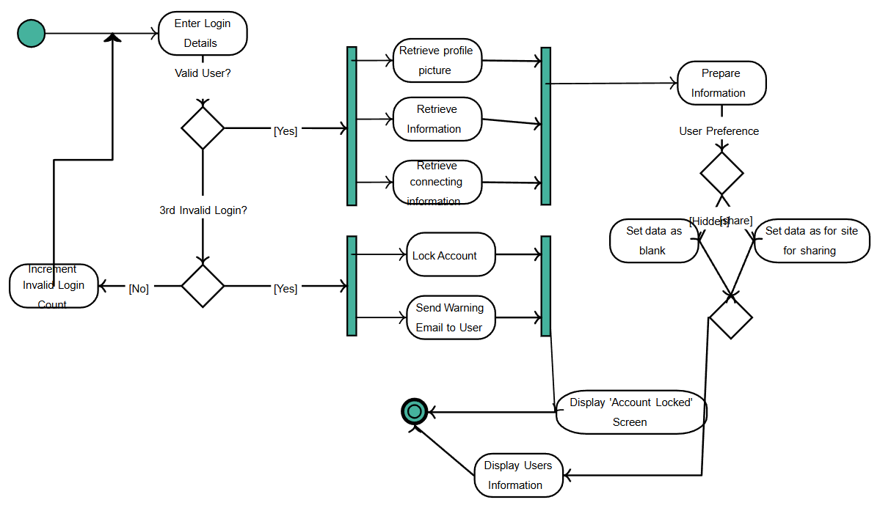

Fig 1.2

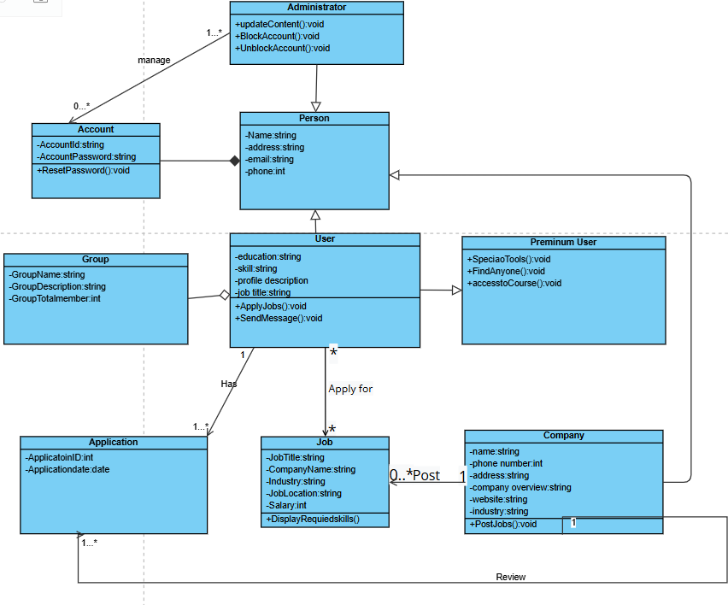

Fig 1.3

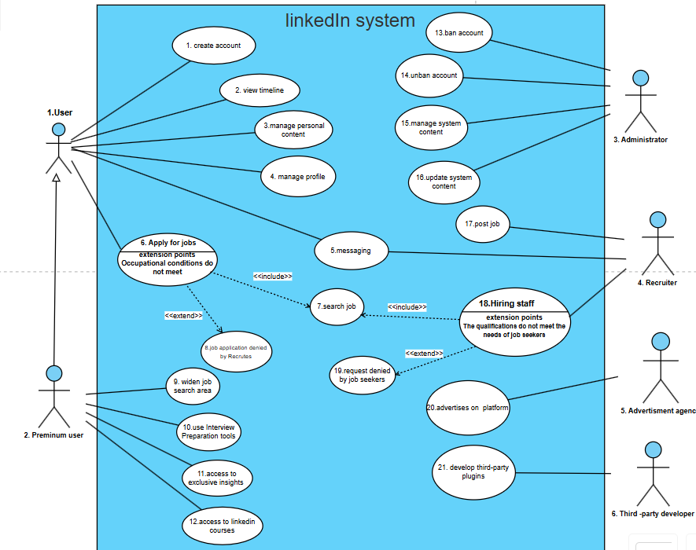

**DISCUSSION ABOUT OTHER MODELS**

1. **Waterfall model**

Waterfall model is time consuming. For a large, evolving platform, this approach would be slow to respond to user feedback, new security concerns, or feature requests. LinkedIn needs a more flexible, iterative approach that allows for rapid updates and continuous deployment.

1. **Incremental model**

It requires resource intensive Integration. With many independent services and modules, integrating new increments into a highly modular microservices structure would become resource-intensive and could cause delays, making it inefficient for LinkedIn’s needs.

1. **Rapid Application Development (RAD)**

Requires a lot of data security. Emphasizes speed over structure, which could increase risks to data integrity and security—critical aspects for LinkedIn, where sensitive user and corporate data are involved.

1. **Spiral Model**

Limited suitability for Frequent Releases. It is most effective in high-risk projects with well-defined phases. LinkedIn’s development process needs to be adaptable and fast-paced to support frequent releases, updates, and maintenance, which would be challenging in the Spiral Model’s framework.

1. **Agile Model**

Linked in used Agile Aspects but not purely Agile. Its iterative focus can become difficult to scale across LinkedIn’s globally distributed microservices architecture. LinkedIn’s architecture requires a higher level of control, orchestration, and standardization than pure Agile typically offers.

1. **Prototyping Model**

Prototyping has a lot of operational complexity. LinkedIn’s services must be thoroughly vetted for security, compliance, and reliability. Prototyping for such a large system would involve considerable time and resources, detracting from the goal of continuous delivery.

**WHY LINKEDIN FAVOURS ALTERNATIVE APPROACHES?**

1. **Continuous Delivery and Deployment**: LinkedIn needs a fast, continuous deployment cycle to remain responsive to user demands and industry changes.
2. **Scalability**: The microservices model allows each service to be independently scalable, which is essential for handling LinkedIn’s large user base and diverse range of services.
3. **Data Security and Compliance**: Data privacy, security, and regulatory compliance are essential, and LinkedIn’s architecture enables continuous monitoring and quick security patches.